Lab - Linux Review

# Objectives

**Part 1: Launch the DEVASC VM**

**Part 2: Review Command Syntax Navigation**

**Part 3: Review File Management**

**Part 4: Review Regular Expressions**

**Part 5: Review System Administration**

# Background / Scenario

In this lab, you review basic Linux skills including command navigation, file management, regular expressions, and system administration. This lab is not meant as a substitute for prior Linux experience and does not necessarily cover all the Linux skills you need for this course. However, this lab should serve as a good measure of your Linux skills and help direct you to where you may need more review.

# Required Resources

* 1 PC with operating system of your choice
* Virtual Box or VMWare
* DEVASC Virtual Machine

# Instructions

## Launch the DEVASC VM

If you have not already completed the **Lab - Install the Virtual Machine Lab Environment**, do so now. If you have already completed that lab, launch the DEVASC VM now.

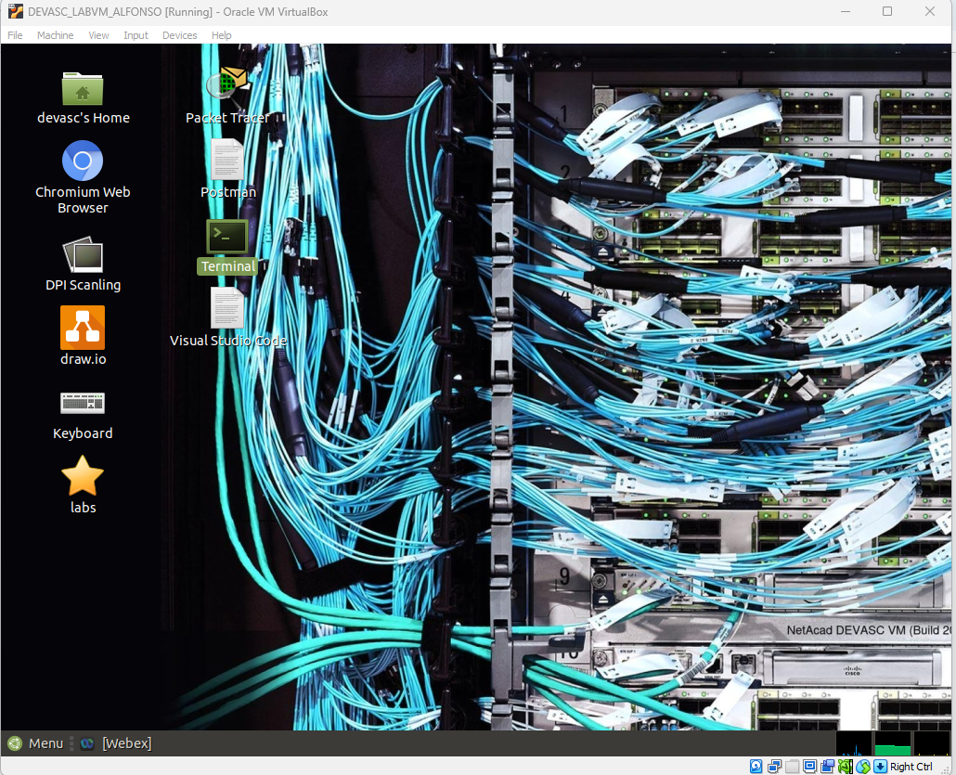

**Figure 1.1 Launch the DEVASC VM.**

## Review Command Syntax Navigation

In this part, you will use the **ls, pwd**, **cd**, and **sudo** commands to review basic command syntax navigation.

### Open a terminal in the DEVASC-LABVM.

* + - 1. Double-click the Terminal Emulator icon on the desktop to open a terminal window.

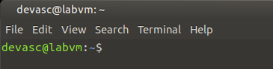

**Figure 2.1 Opening a terminal.**

### Navigate directories.

* + - 1. Use the **ls** command to display a listing of the current directory. Remember that commands are case-sensitive.

devasc@**labvm:~$ ls**

Desktop Downloads Music Public Templates

Documents labs Pictures snap Videos

devasc@labvm:~$

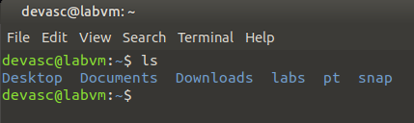

**Figure 3.1 Accessing the command “ls”.**

* + - 1. Use the **ls** command with the **labs** argument to display the contents of the labs folder.

devasc@labvm:~$ **ls labs**

devnet-src

devasc@labvm:~$

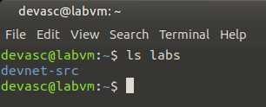

**Figure 3.2 Accessing the command “ls labs”.**

* + - 1. Use the **ls** command with the **-l** option to display a "long display" of the contents of the current directory.

devasc@labvm:~$ **ls -l**

total 40

drwxr-xr-x 2 devasc devasc 4096 Mar 30 21:25 Desktop

drwxr-xr-x 2 devasc devasc 4096 Apr 15 19:09 Documents

drwxr-xr-x 2 devasc devasc 4096 Apr 15 19:09 Downloads

drwxr-xr-x 5 devasc devasc 4096 Mar 30 21:21 labs

drwxr-xr-x 2 devasc devasc 4096 Apr 15 19:09 Music

drwxr-xr-x 2 devasc devasc 4096 Apr 15 19:09 Pictures

drwxr-xr-x 2 devasc devasc 4096 Apr 15 19:09 Public

drwxr-xr-x 5 devasc devasc 4096 Mar 30 21:24 snap

drwxr-xr-x 2 devasc devasc 4096 Apr 15 19:09 Templates

drwxr-xr-x 2 devasc devasc 4096 Apr 15 19:09 Videos

devasc@labvm:~$

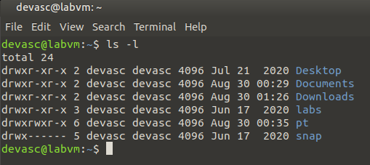

**Figure 3.3 Accessing the command “ls -l”.**

* + - 1. Use the **ls** command with the **-r** option to display the contents of the current directory in reverse alphabetical order.

devasc@labvm:~$ **ls -r**

Videos snap Pictures labs Documents

Templates Public Music Downloads Desktop

devasc@labvm:~$

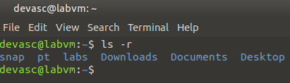

**Figure 3.4 Accessing the command “ls -r”.**

* + - 1. Multiple options can be used at the same time. Use the **ls** command with both the **-l** and **-r** options to display the contents of the current directory both in long and reverse order.

devasc@labvm:~$ **ls -lr**

total 40

drwxr-xr-x 2 devasc devasc 4096 Apr 15 19:09 Videos

drwxr-xr-x 2 devasc devasc 4096 Apr 15 19:09 Templates

drwxr-xr-x 5 devasc devasc 4096 Mar 30 21:24 snap

drwxr-xr-x 2 devasc devasc 4096 Apr 15 19:09 Public

drwxr-xr-x 2 devasc devasc 4096 Apr 15 19:09 Pictures

drwxr-xr-x 2 devasc devasc 4096 Apr 15 19:09 Music

drwxr-xr-x 5 devasc devasc 4096 Mar 30 21:21 labs

drwxr-xr-x 2 devasc devasc 4096 Apr 15 19:09 Downloads

drwxr-xr-x 2 devasc devasc 4096 Apr 15 19:09 Documents

drwxr-xr-x 2 devasc devasc 4096 Mar 30 21:25 Desktop

devasc@labvm:~$

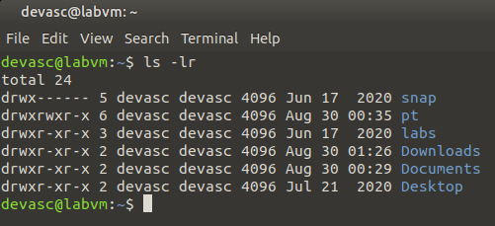

**Figure 3.5 Accessing the command “ls -lr”.**

* + - 1. There are many more options that can be used with the **ls** command. Use the **man** command with the argument **ls** to see all of the possibilities in the manual. The **man** command can be used to look up any command within the system. Use the space bar to advance to subsequent screens. Press **q** to quit.

devasc@labvm:~$ **man ls**

(The command line disappears and the manual page for ls opens.)

LS(1) User Commands LS(1)

NAME

ls - list directory contents

SYNOPSIS

ls [OPTION]... [FILE]...

DESCRIPTION

List information about the FILEs (the current directory by default).

Sort entries alphabetically if none of -cftuvSUX nor --sort is speci‐

fied.

Mandatory arguments to long options are mandatory for short options

too.

-a, --all

do not ignore entries starting with .

-A, --almost-all

do not list implied . and ..

--author

Manual page ls(1) line 1 (press h for help or q to quit)

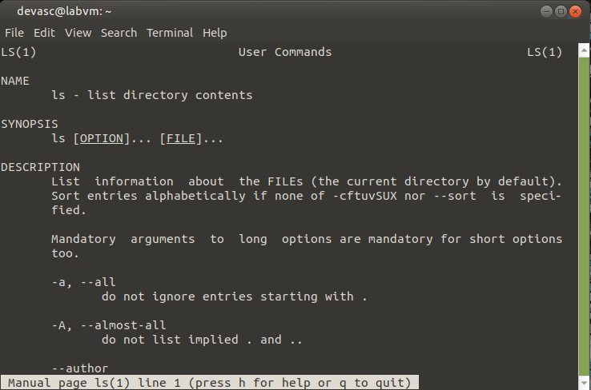

**Figure 3.6 Accessing the command “man ls”.**

* + - 1. You can also use **--help** argument after most commands to see a shorter summary of all the available command options.

devasc@labvm:~$ **ls --help**

Usage: ls [OPTION]... [FILE]...

List information about the FILEs (the current directory by default).

Sort entries alphabetically if none of -cftuvSUX nor --sort is specified.

Mandatory arguments to long options are mandatory for short options too.

-a, --all do not ignore entries starting with .

-A, --almost-all do not list implied . and ..

(Output Omitted)

devasc@labvm:~$

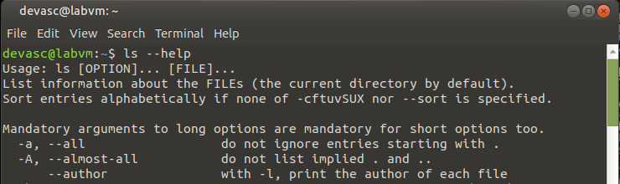

**Figure 3.7 Accessing the command “ls --help”.**

* + - 1. Use the **pwd** command to display the current working directory.

devasc@labvm:~$ **pwd**

/home/devasc

devasc@labvm:~$

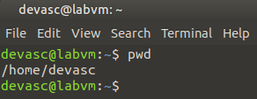

**Figure 3.8 Accessing the command “pwd”.**

* + - 1. Use the **cd** command to change the directory to /home/devasc/Documents.

devasc@labvm:~$ **cd Documents**

devasc@labvm:~/Documents$

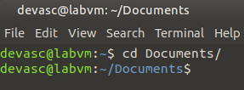

**Figure 3.9 Accessing the command “cd Documents”.**

* + - 1. Use the **cd** command with the **/** symbol to change directories to the root directory. Use **pwd** again to see that you are now in the root directory.

devasc@labvm:~/Documents$ **cd /**

devasc@labvm:/$ **pwd**

/

devasc@labvm:/$

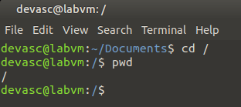

**Figure 3.10 Accessing the command “cd /” and “pwd” .**

* + - 1. Return to the **/home/devasc/Documents** directory. Tip: You can move one directory at a time or all the way to a destination. To quickly enter the command, type the first few letters of the directory name and press **Tab** for the system to automatically enter the rest of the name. Remember that names are case-sensitive.

devasc@labvm:/$ **cd /home/devasc/Documents/**

devasc@labvm:~/Documents$

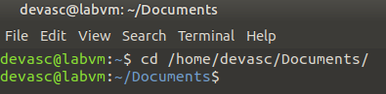

**Figure 3.11 Accessing the command “cd /home/devasc/Documents/”.**

* + - 1. Use the **..** characters to move up a single directory. Use **pwd** again to see you are back in the user’s home directory.

devasc@labvm:~/Documents$ **cd ..**

devasc@labvm:~$ **pwd**

/home/devasc

devasc@labvm:~$

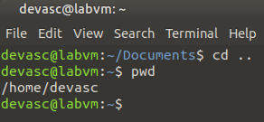

**Figure 3.12 Accessing the command “cd ..” and “pwd”.**

### Use super user commands for administrative access.

* + - 1. Use the **sudo** command to issue a single command as the root user. A new terminal will not be created. Use the **sudo apt-get update** command to update to refresh the list of available packages installed on the VM. This command will not work without using the **sudo** command.

**Note**: Your output will most likely be different.

devasc@labvm:~$ **sudo apt-get update**

Get:1 http://security.ubuntu.com/ubuntu focal-security InRelease [97.9 kB]

Get:2 http://us.archive.ubuntu.com/ubuntu focal InRelease [265 kB]

Get:3 http://us.archive.ubuntu.com/ubuntu focal-updates InRelease [89.1 kB]

Get:4 http://us.archive.ubuntu.com/ubuntu focal-backports InRelease [89.2 kB]

Get:5 http://us.archive.ubuntu.com/ubuntu focal/main i386 Packages [723 kB]

Get:6 http://us.archive.ubuntu.com/ubuntu focal/main amd64 Packages [981 kB]

(Output Omitted)

Fetched 677 kB in 2s (346 kB/s)

Reading package lists... Done

devasc@labvm:~$

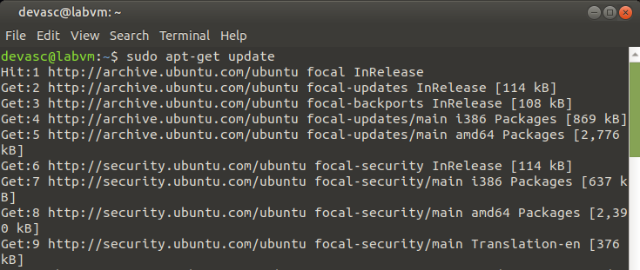

**Figure 4.1 Accessing the command “sudo apt-get update”.**

## Review File Management

In this part, you will review file permissions, change file permissions and ownership, move files, copy files, remove files, and view files.

### Review file permissions.

* + - 1. Use the **ls Desktop -l** to display the contents of the Desktop folder.

devasc@labvm:~$ **ls Desktop -l**

total 28

-rwxr-xr-x 1 devasc devasc 1095 Mar 30 21:24 chromium_chromium.desktop

-rwxr-xr-x 1 devasc devasc 401 Mar 30 21:25 cisco-packet-tracer_cisco-pacet-tracer.desktop

-rwxr-xr-x 1 devasc devasc 776 Mar 30 21:23 code.desktop

-rwxr-xr-x 1 devasc devasc 373 Mar 30 21:25 drawio_drawio.desktop

-rwxr-xr-x 1 devasc devasc 250 Mar 30 21:21 exo-terminal-emulator.desktop

-rwxr-xr-x 1 devasc devasc 99 Mar 30 21:21 labs.desktop

-rwxr-xr-x 1 devasc devasc 334 Mar 30 21:24 postman_postman.desktop

devasc@labvm:~$

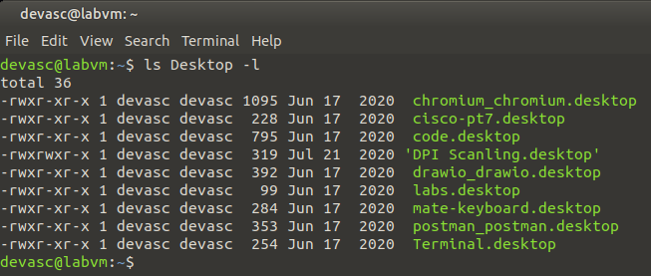

**Figure 5.1 Accessing the command “ls Desktop -l”.**

* + - 1. Answer the following questions about the output above. If necessary, search the internet for information of Linux file permission shown in the output of the **ls** command.

#### Questions

What does the initial dash represent in the permission information?

***The initial dash represents a regular file in the file type field.***

What would be in the place of the dash if the item was a directory?

***It would be a “d” if the item was a directory.***

What do the next three letters or dashes represent in the permission information?

***The letters represent the permissions of the file owner over the file.***

What do the middle three letters or dashes represent in the permission information?

***The middle three letters represent the group over the file.***

What do the last three letters or dashes represent in the permission information?

***The last three letters represent the permissions others have over the file.***

What does the first instance of "devasc" in the permission information indicate?

***The first instance of “devasc” indicates the user owner field and is the owner of the file.***

What does the second instance of "devasc" in the permission information indicate?

***The second instance of “devasc” indicates the owner field and is the group of the file.***

What does a permission type of "r" mean?

***Type of “r” means a permission of “read”, allowing for file contents to be read or copied.***

What does a permission type of "w" mean?

***Type of “w” means a permission of “write”, allowing contents to be modified or overwritten. It also allows files to be added or removed from a directory.***

What does a permission type of "x" mean?

***Type of “x” means a permission of “execute”, allowing for a file to be run as a process but script files require read permission.***

### Change file permissions and ownership.

* + - 1. Use the command **cd** to change to the Documents directory.

devasc@labvm:~$ **cd Documents/**

devasc@labvm:~/Documents$

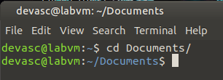

**Figure 6.1 Accessing the command “cd Documents/”.**

* + - 1. Use the command **echo** to create a shell script file, that will have the command **ls ../Desktop** inside the file. Remember that the greater than (>) character redirects command output to a file.

devasc@labvm:~/Documents$ **echo "ls ../Desktop" > myfile.sh**

devasc@labvm:~/Documents$

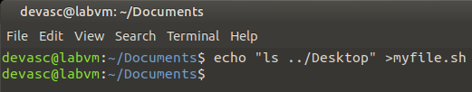

**Figure 6.2 Accessing the command “echo "ls ../Desktop" > myfile.sh”.**

* + - 1. The **myfile.sh** script is stored in the **/Documents** directory. Use the **cat** command to view the only command in the script. This file will be used as an example to modify permissions and ownership.

devasc@labvm:~/Documents$ **cat myfile.sh**

ls ../Desktop

devasc@labvm:~/Documents$

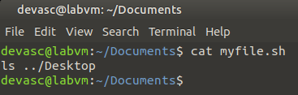

**Figure 6.3 Accessing the command "cat myfile.sh”.**

* + - 1. Use the command **./myfile.sh** to run the script. Access is denied because you must set the permission of executable on the file.

devasc@labvm:~/Documents$ **./myfile.sh**

bash: ./myfile.sh: Permission denied

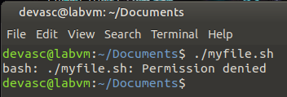

**Figure 6.4 Accessing the command “./myfile.sh”.**

* + - 1. Use the command **ls -l myfile.sh** to view the current file permissions.

devasc@labvm:~/Documents$ **ls -l myfile.sh**

-rw-rw-r-- 1 devasc devasc 14 Apr 16 12:46 myfile.sh

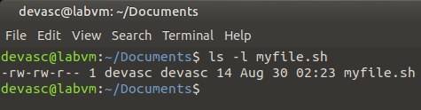

**Figure 6.5 Accessing the command “ls -l myfile.sh”.**

* + - 1. Use the command **chmod +x myfile.sh** to allow you to execute the file.

devasc@labvm:~/Documents$ **chmod +x myfile.sh**

devasc@labvm:~/Documents$

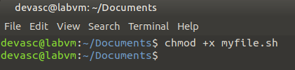

**Figure 6.6 Accessing the command “chmod +x myfile.sh”.**

* + - 1. Use the command **./myfile.sh** to run the script.

devasc@labvm:~/Documents$ **./myfile.sh**

chromium_chromium.desktop exo-terminal-emulator.desktop

cisco-packet-tracer_cisco-pacet-tracer.desktop labs.desktop

code.desktop postman_postman.desktop

drawio_drawio.desktop

devasc@labvm:~/Documents$

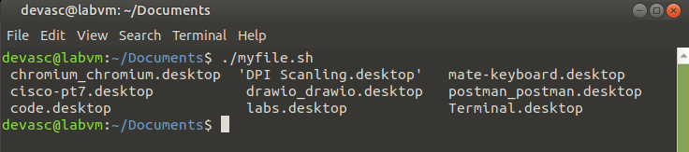

**Figure 6.7 Accessing the command “./myfile.sh”.**

* + - 1. Use the command **sudo chown root myfile.sh** to change the ownership of the file to "root".

devasc@labvm:~/Documents$ **sudo chown root myfile.sh**

devasc@labvm:~/Documents$

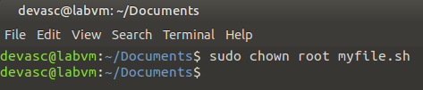

**Figure 6.8 Accessing the command “sudo chown root myfile.sh”.**

* + - 1. Display the permissions of the myfile.sh file.

devasc@labvm:~/Documents$ **ls -l**

total 4

-rwxrwxr-x 1 root devasc 14 Apr 16 21:28 myfile.sh

devasc@labvm:~/Documents$

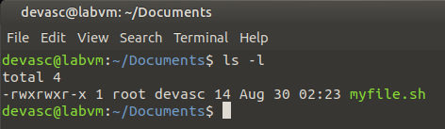

**Figure 6.10 Accessing the command “ls -l”.**

### Use the move files command.

* + - 1. Use the command **mv** to move the myfile.sh file to the desktop.

devasc@labvm:~/Documents$ **mv myfile.sh /home/devasc/Desktop/**

devasc@labvm:~/Documents$

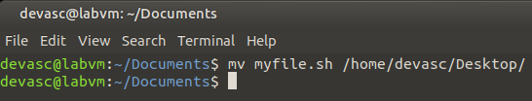

**Figure 7.1 Accessing the command “mv myfile.sh /home/devasc/Desktop/”.**

* + - 1. Display the contents of the Desktop folder.

devasc@labvm:~/Documents$ **ls ../Desktop/**

chromium_chromium.desktop exo-terminal-emulator.desktop

cisco-packet-tracer_cisco-pacet-tracer.desktop labs.desktop

code.desktop myfile.sh

drawio_drawio.desktop postman_postman.desktop

devasc@labvm:~/Documents$

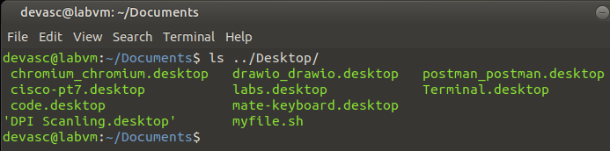

**Figure 7.2 Accessing the command “ls ../Desktop/”.**

* + - 1. Return the file to the Documents folder.

devasc@labvm:~/Documents$ **mv ../Desktop/myfile.sh myfile.sh**

devasc@labvm:~/Documents$

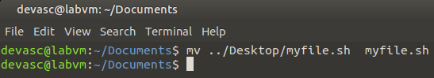

**Figure 7.3 Accessing the command “mv ../Desktop/myfile.sh myfile.sh”.**

* + - 1. Use the command **mv** to rename myfile.sh to myfile_renamed.sh.

devasc@labvm:~/Documents$ **mv myfile.sh myfile_renamed.sh**

devasc@labvm:~/Documents$ **ls**

myfile_renamed.sh

devasc@labvm:~/Documents$

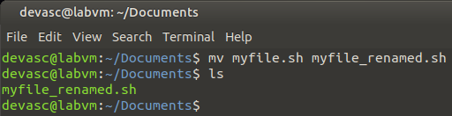

**Figure 7.4 Accessing the command “mv myfile.sh myfile_renamed.sh”.**

### Use the copy files command.

* + - 1. Use the command **cp** to make a copy of the myfile_renamed.sh file.

devasc@labvm:~/Documents$ **cp myfile_renamed.sh myfile_renamed_and_copied.sh**

devasc@labvm:~/Documents$ **ls**

myfile_renamed_and_copied.sh myfile_renamed.sh

devasc@labvm:~/Documents$

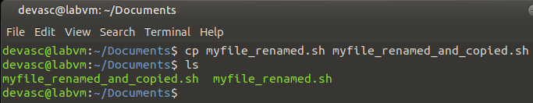

**Figure 8.1 Accessing the command “cp myfile_renamed.sh myfile_renamed_and_copied.sh”.**

### Use the remove files command.

Use the **rm** command to remove the **myfile_renamed_and_copied.sh** file.

devasc@labvm:~/Documents$ **rm myfile_renamed_and_copied.sh**

devasc@labvm:~/Documents$ **ls**

mbr.img myfile_renamed.sh

devasc@labvm:~/Documents$

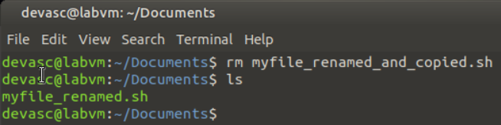

**Figure 9.1 Accessing the command “rm myfile_renamed_and_copied.sh”.**

### Use the standard output redirect.

* + - 1. Use the redirect (**>**) to place text into a new file called **linux.txt**.

devasc@labvm:~$ **echo "Linux is AWESOME!" > linux.txt**

devasc@labvm:~$

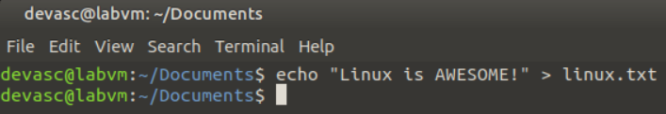

**Figure 10.1 Accessing the command “echo "Linux is AWESOME!" > linux.txt”.**

* + - 1. Use the command **cat** to redirect the contents of **linux.txt** to another file.

devasc@labvm:~$ **cat linux.txt > linux2.txt**

devasc@labvm:~$

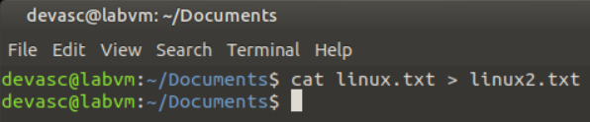

**Figure 10.2 Accessing the command “echo "cat linux.txt > linux2.txt”.**

* + - 1. Use the command **cat** to view the contents of **linux2.txt**.

devasc@labvm:~$ **cat linux2.txt**

Linux is AWESOME!

devasc@labvm:~$

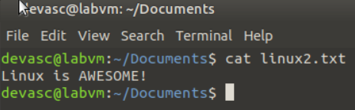

**Figure 10.3 Accessing the command “cat linux2.txt”.**

* + - 1. Use the **echo** command to append text to the **linux2.txt** file.

devasc@labvm:~$ **echo "I LOVE Linux!" >> linux2.txt**

devasc@labvm:~$

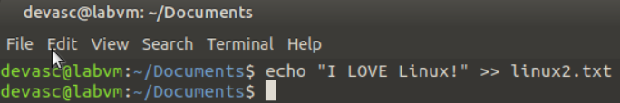

**Figure 10.4 Accessing the command “echo "I LOVE Linux!" >> linux2.txt”.**

* + - 1. Use the **cat** command to view the contents of the **linux2.txt** file.

devasc@labvm:~$ **cat linux2.txt**

Linux is AWESOME!

I LOVE Linux!

devasc@labvm:~$

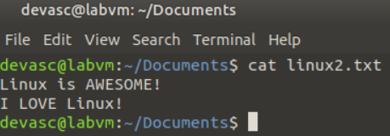

**Figure 10.5 Accessing the command “echo "cat linux2.txt”.**

* + - 1. Use the **echo** command to overwrite the contents of a file using the single angle bracket.

devasc@labvm:~$ echo "Linux is POWERFUL!" > linux.txt

devasc@labvm:~$

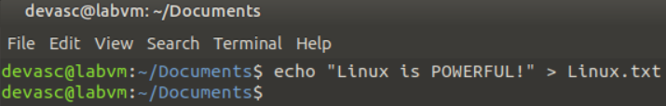

**Figure 10.6 Accessing the command “echo "Linux is POWERFUL!" > linux.txt”.**

* + - 1. Use the **cat** command to view the contents of the **linux.txt** file. Notice that the previous state “Linux is AWESOME!” was overwritten.

devasc@labvm:~$ **cat linux.txt**

Linux is POWERFUL!

devasc@labvm:~$

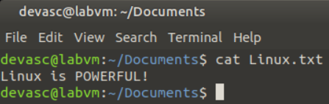

**Figure 10.7 Accessing the command “cat linux.txt”.**

### Use the vi text editor.

* + - 1. Use the following command to start the **vi** text editor and open a text file.

devasc@labvm:~$ **vi linux2.txt**

The following content is shown in the editor window:

Linux is AWESOME!

I LOVE Linux!

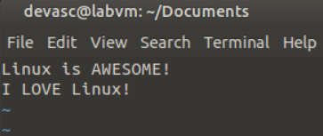

**Figure 11.1 Accessing the command “vi linux2.txt”.**

* + - 1. Use the text editor to change the content to the following:

Linux is Linux

I am AWESOME!

The **a** key will allow you to enter edit mode, appending after the cursor’s position, while the **i** key will allow you to enter edit mode, inserting at the cursor’s position. You will need to use the **Esc** key to enter command mode to move around. Remember that **d** will delete (cut), **y** will yank (copy), and **p** will put (paste) the current line with the cursor.

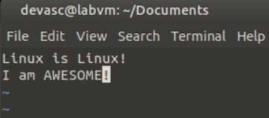

**Figure 11.2 Changing the content.**

* + - 1. Save the text to a new file called "linux3.txt". Remember that you will need to be in the command mode and type a colon ( **:** ) to enter ex mode so that you can write (save) the document ( **:w linux3.txt**). You can then use the quit (exit) command ( **:q**) to exit the vi editor.
      2. Use the **cat** command to view the contents of the linux3.txt file.

devasc@labvm:~$ **cat linux3.txt**

Linux is Linux

I am AWESOME!

devasc@labvm:~$

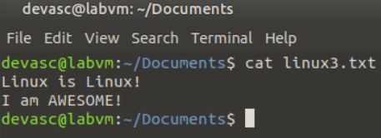

**Figure 11.3 Accessing the command “cat linux3.txt”.**

## Review Regular Expressions

In this part, you use the **grep** command to review how you can use regular expressions for filtering.

**Note**: Your output may differ than the output shown below as the state of the VM is based on the most recent iteration that you downloaded as well as any changes you may have made. However, you should get some output from the **passwd** file but your highlighted output will differ.

* + - 1. Use the **grep** command to filter the contents of the passwd file to display the line from the passwd file containing **devasc**. Notice that the two instances of **devasc** are highlighted. Also notice that the **grep** command is case-sensitive. The instance of **DEVASC** is not highlighted.

devasc@labvm:~$ **grep devasc /etc/passwd**

devasc:x:900:900:DEVASC,,,:/home/devasc:/bin/bash

devasc@labvm:~$

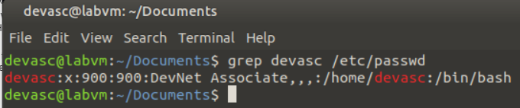

**Figure 12.1 Accessing the command “grep devasc /etc/passwd”.**

* + - 1. Use the **grep** command to show how many times **root** appears in the passwd file. Notice that all three instances of root are highlighted.

devasc@labvm:~$ **grep root /etc/passwd**

root:x:0:0:root:/root:/bin/bash

devasc@labvm:~$

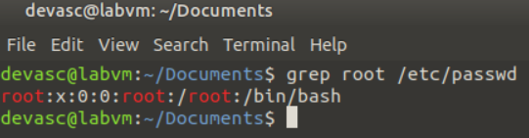

**Figure 12.2 Accessing the command “grep root /etc/passwd”.**

* + - 1. Use the **grep** command with the anchor character **^** to find the word, but only at the beginning of the line. Notice that only the word at the beginning of the line is highlighted.

devasc@labvm:~$ **grep '^root' /etc/passwd**

root:x:0:0:root:/root:/bin/bash

devasc@labvm:~$

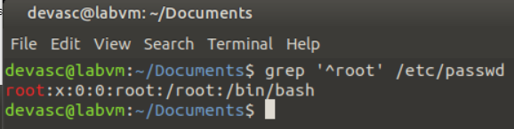

**Figure 12.3 Accessing the command “grep '^root' /etc/passwd”.**

* + - 1. Use the **grep** command with the anchor character **$** to find a word at the end of a line.

devasc@labvm:~$ **grep 'false$' /etc/passwd**

tss:x:106:114:TPM software stack,,,:/var/lib/tpm:/bin/false

lightdm:x:107:117:Light Display Manager:/var/lib/lightdm:/bin/false

hplip:x:115:7:HPLIP system user,,,:/run/hplip:/bin/false

devasc@labvm:~$

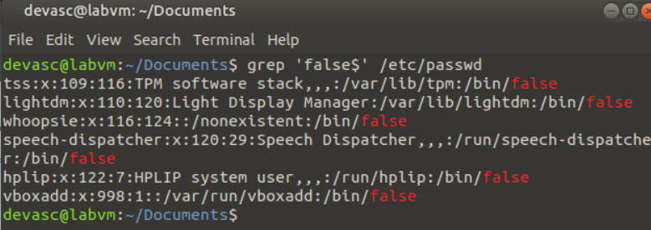

**Figure 12.4 Accessing the command “grep 'false$' /etc/passwd”.**

* + - 1. Use the **grep** command with the anchor character **.** to match specific length words with different letters in them. Notice that not only is **daem** highlighted, but also **dnsm** is highlighted.

devasc@labvm:~$ **grep 'd..m' /etc/passwd**

daemon:x:1:1:daemon:/usr/sbin:/usr/sbin/nologin

dnsmasq:x:109:65534:dnsmasq,,,:/var/lib/misc:/usr/sbin/nologin

avahi-autoipd:x:110:121:Avahi autoip daemon,,,:/var/lib/avahi-autoipd:/usr/sbin/nologin

usbmux:x:111:46:usbmux daemon,,,:/var/lib/usbmux:/usr/sbin/nologin

avahi:x:113:122:Avahi mDNS daemon,,,:/var/run/avahi-daemon:/usr/sbin/nologin

colord:x:116:125:colord colour management daemon,,,:/var/lib/colord:/usr/sbin/nologin

pulse:x:117:126:PulseAudio daemon,,,:/var/run/pulse:/usr/sbin/nologin

devasc@labvm:~$

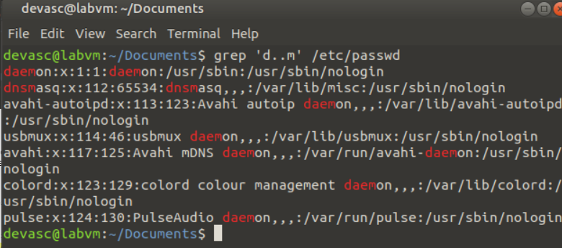

**Figure 12.5 Accessing the command “grep 'd..m' /etc/passwd”.**

* + - 1. Use the **grep** command to find lines where only the numbers 8 or 9 are present. Notice that only the lines containing an 8, a 9, or both are returned.

devasc@labvm:~$ **grep '[8-9]' /etc/passwd**

mail:x:8:8:mail:/var/mail:/usr/sbin/nologin

news:x:9:9:news:/var/spool/news:/usr/sbin/nologin

list:x:38:38:Mailing List Manager:/var/list:/usr/sbin/nologin

irc:x:39:39:ircd:/var/run/ircd:/usr/sbin/nologin

uuidd:x:103:109::/run/uuidd:/usr/sbin/nologin

devasc:x:900:900:DEVASC,,,:/home/devasc:/bin/bash

systemd-network:x:999:999:systemd Network Management:/:/usr/sbin/nologin

systemd-resolve:x:998:998:systemd Resolver:/:/usr/sbin/nologin

systemd-timesync:x:997:997:systemd Time Synchronization:/:/usr/sbin/nologin

systemd-coredump:x:996:996:systemd Core Dumper:/:/usr/sbin/nologin

rtkit:x:108:119:RealtimeKit,,,:/proc:/usr/sbin/nologin

dnsmasq:x:109:65534:dnsmasq,,,:/var/lib/misc:/usr/sbin/nologin

devasc@labvm:~$

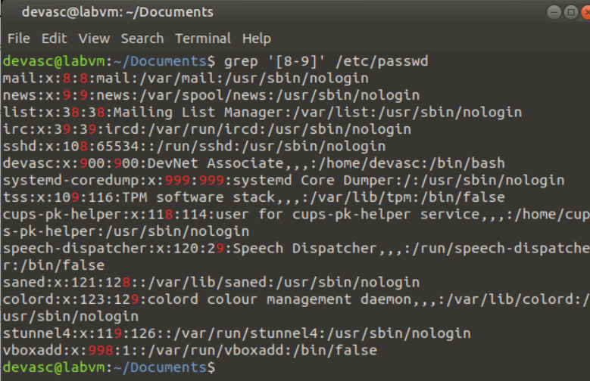

**Figure 12.6 Accessing the command “grep '[8-9]' /etc/passwd”.**

* + - 1. Use the **grep** command to find literal characters. Notice that only the lines containing a comma are returned.

devasc@labvm:~$ **grep '[,]' /etc/passwd**

devasc:x:900:900:DEVASC,,,:/home/devasc:/bin/bash

tss:x:106:114:TPM software stack,,,:/var/lib/tpm:/bin/false

rtkit:x:108:119:RealtimeKit,,,:/proc:/usr/sbin/nologin

dnsmasq:x:109:65534:dnsmasq,,,:/var/lib/misc:/usr/sbin/nologin

avahi-autoipd:x:110:121:Avahi autoip daemon,,,:/var/lib/avahi-autoipd:/usr/sbin/nologin

usbmux:x:111:46:usbmux daemon,,,:/var/lib/usbmux:/usr/sbin/nologin

kernoops:x:112:65534:Kernel Oops Tracking Daemon,,,:/:/usr/sbin/nologin

avahi:x:113:122:Avahi mDNS daemon,,,:/var/run/avahi-daemon:/usr/sbin/nologin

hplip:x:115:7:HPLIP system user,,,:/run/hplip:/bin/false

colord:x:116:125:colord colour management daemon,,,:/var/lib/colord:/usr/sbin/nologin

pulse:x:117:126:PulseAudio daemon,,,:/var/run/pulse:/usr/sbin/nologin

devasc@labvm:~$

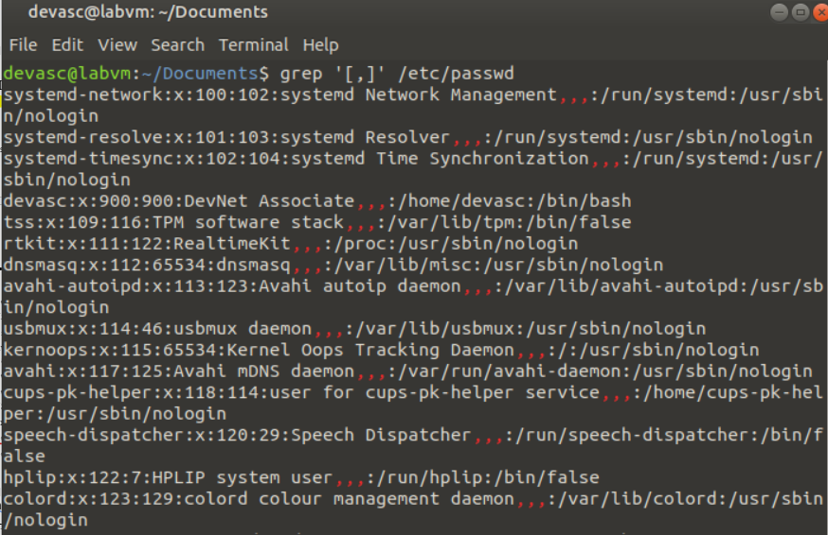

**Figure 12.7 Accessing the command “grep '[,]' /etc/passwd”.**

* + - 1. Use the **grep** command to find occurrences of zero or more of the pattern preceding it. Notice that only the lines with either **new** and **ne** are returned.

devasc@labvm:~$ **grep 'new*' /etc/passwd**

news:x:9:9:news:/var/spool/news:/usr/sbin/nologin

nobody:x:65534:65534:nobody:/nonexistent:/usr/sbin/nologin

messagebus:x:100:103::/nonexistent:/usr/sbin/nologin

_apt:x:102:65534::/nonexistent:/usr/sbin/nologin

tcpdump:x:104:110::/nonexistent:/usr/sbin/nologin

systemd-network:x:999:999:systemd Network Management:/:/usr/sbin/nologin

kernoops:x:112:65534:Kernel Oops Tracking Daemon,,,:/:/usr/sbin/nologin

saned:x:114:124::/var/lib/saned:/usr/sbin/nologin

devasc@labvm:~$

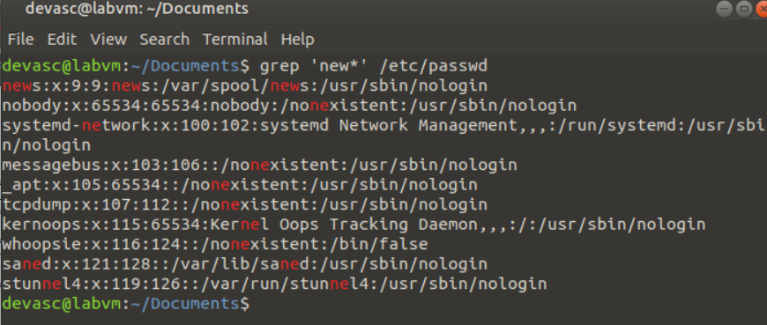

**Figure 12.8 Accessing the command “grep 'new*' /etc/passwd”.**

## Review System Administration

In this part, you will review basic Linux system administration tasks including shutting down the computer, viewing and testing the network configuration, viewing processes, managing installation packages, updating user passwords, adding content to files, and using text editors.

### Shut down the computer.

* + - 1. Use the command **shutdown now** to initiate a shutdown of the OS (and the VM) immediately. You do not have to perform this action as the VM will shut down and you will need to restart it manually. Formats of this time argument can be the word **now**, a time of day in the format **hh:mm** or the number of minutes to delay in the format **+minutes**.

devasc@labvm:~$ **shutdown now**

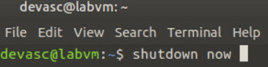

**Figure 13.1 Accessing the command “shutdown now”.**

* + - 1. Use the command **date** to check set date of the OS.

devasc@labvm:~$ **date**

Fri 17 Apr 2020 08:53:20 PM UTC

devasc@labvm:~$

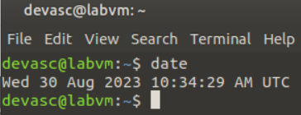

**Figure 13.2 Accessing the command “date”.**

* + - 1. Use the command **shutdown +1 "Come back soon!"** to shut down the OS in 1 minute and display the message "Come back soon!". Be sure to cancel or your VM will shut down.

devasc@labvm:~$ **shutdown +1 "Come back soon!"**

Shutdown scheduled for Fri 2020-04-17 20:57:13 UTC, use 'shutdown -c' to cancel.

devasc@labvm:~$ **shutdown -c**

devasc@labvm:~$

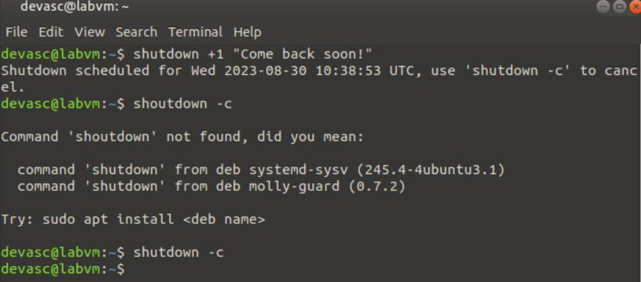

**Figure 13.3 Accessing the command “shutdown +1 "Come back soon!"”.**

### View and test the network configuration.

* + - 1. Use the **ip address** command to display the network configuration. The output is a bit more detailed. For example, notice that five IPv4 addresses are shown for the **dummy0** interface.

devasc@labvm:~$ **ip address**

1: lo: <LOOPBACK,UP,LOWER_UP> mtu 65536 qdisc noqueue state UNKNOWN group default qlen 1000

link/loopback 00:00:00:00:00:00 brd 00:00:00:00:00:00

inet 127.0.0.1/8 scope host lo

valid_lft forever preferred_lft forever

inet6 ::1/128 scope host

valid_lft forever preferred_lft forever

2: enp0s3: <BROADCAST,MULTICAST,UP,LOWER_UP> mtu 1500 qdisc fq_codel state UP group default qlen 1000

link/ether 08:00:27:ce:2b:8b brd ff:ff:ff:ff:ff:ff

inet 10.0.2.15/24 brd 10.0.2.255 scope global dynamic enp0s3

valid_lft 75746sec preferred_lft 75746sec

inet6 fe80::a00:27ff:fece:2b8b/64 scope link

valid_lft forever preferred_lft forever

3: dummy0: <BROADCAST,NOARP,UP,LOWER_UP> mtu 1500 qdisc noqueue state UNKNOWN group default qlen 1000

link/ether 46:8b:41:b5:de:aa brd ff:ff:ff:ff:ff:ff

inet 192.0.2.1/32 scope global dummy0

valid_lft forever preferred_lft forever

inet 192.0.2.2/32 scope global dummy0

valid_lft forever preferred_lft forever

inet 192.0.2.3/32 scope global dummy0

valid_lft forever preferred_lft forever

inet 192.0.2.4/32 scope global dummy0

valid_lft forever preferred_lft forever

inet 192.0.2.5/32 scope global dummy0

valid_lft forever preferred_lft forever

inet6 fe80::448b:41ff:feb5:deaa/64 scope link

valid_lft forever preferred_lft forever

devasc@labvm:~$

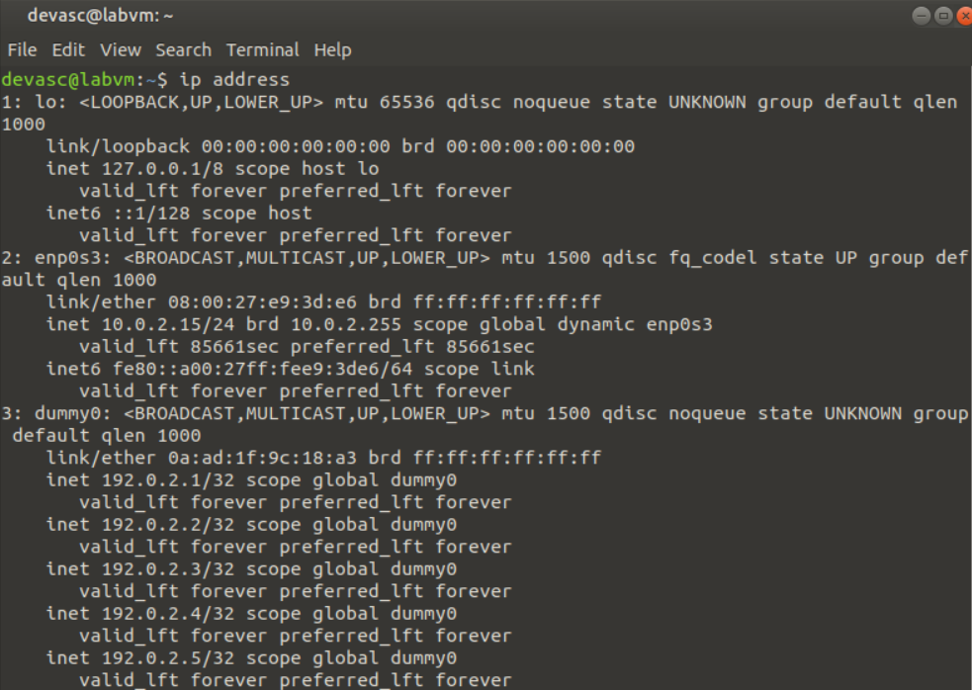

**Figure 14.1 Accessing the command “ip address”.**

* + - 1. Use the command **ping** with the options **-c 4**  to ping a computer on your local network four times. You must use a valid IP address of a device on your local network. The following example is using 192.168.1.1, but your network will most likely have different IPv4 addresses.

devasc@labvm:~$ **ping -c 4 192.168.1.1**

PING 192.168.1.1 (192.168.1.1) 56(84) bytes of data.

64 bytes from 192.168.1.1: icmp_seq=1 ttl=63 time=1.13 ms

64 bytes from 192.168.1.1: icmp_seq=2 ttl=63 time=2.30 ms

64 bytes from 192.168.1.1: icmp_seq=3 ttl=63 time=1.31 ms

64 bytes from 192.168.1.1: icmp_seq=4 ttl=63 time=2.49 ms

--- 192.168.1.1 ping statistics ---

4 packets transmitted, 4 received, 0% packet loss, time 3005ms

rtt min/avg/max/mdev = 1.130/1.809/2.492/0.594 ms

devasc@labvm:~$

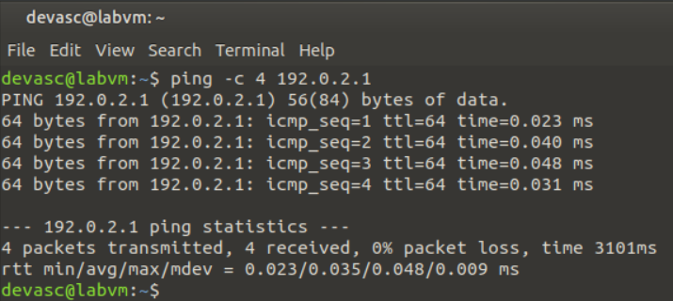

**Figure 14.2 Accessing the command “ping -c 4 192.0.2.1”.**

* + - 1. You can also ping a name and Domain Name System (DNS) will resolve the name to an IP address. For example, ping Cisco’s website. Your VM will send out a DNS request first to get the IP address and then send the ping packets. The DNS process is not shown in the ping output.

devasc@labvm:~$ **ping -c 4 www.cisco.com**

PING e2867.dsca.akamaiedge.net (23.204.11.200) 56(84) bytes of data.

64 bytes from a23-204-11-200.deploy.static.akamaitechnologies.com (23.204.11.200): icmp_seq=1 ttl=58 time=185 ms

64 bytes from a23-204-11-200.deploy.static.akamaitechnologies.com (23.204.11.200): icmp_seq=2 ttl=58 time=28.8 ms

64 bytes from a23-204-11-200.deploy.static.akamaitechnologies.com (23.204.11.200): icmp_seq=3 ttl=58 time=28.8 ms

64 bytes from a23-204-11-200.deploy.static.akamaitechnologies.com (23.204.11.200): icmp_seq=4 ttl=58 time=26.4 ms

--- e2867.dsca.akamaiedge.net ping statistics ---

4 packets transmitted, 4 received, 0% packet loss, time 3007ms

rtt min/avg/max/mdev = 26.443/67.339/185.363/68.147 ms

devasc@labvm:~$

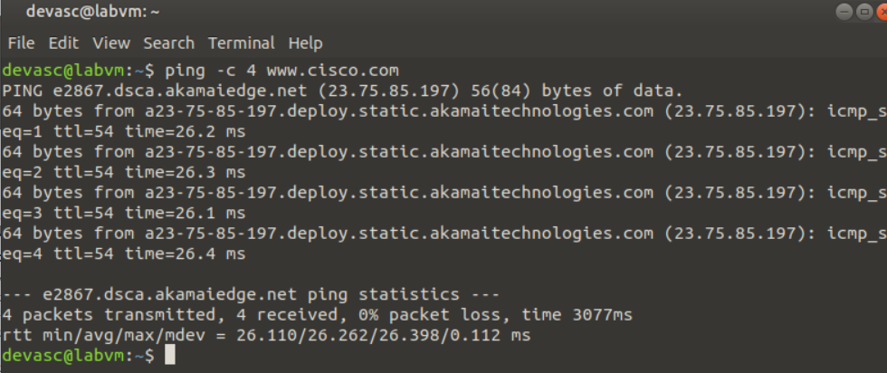

**Figure 14.3 Accessing the command “ping -c 4 www.cisco.com”.**

### View Processes

* + - 1. Use the **ps** command to display the processes that are running in the current terminal.

devasc@labvm:~$ **ps**

PID TTY TIME CMD

1416 pts/0 00:00:00 bash

1453 pts/0 00:00:00 ps

devasc@labvm:~$

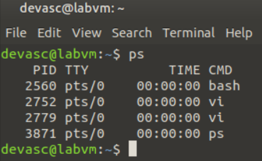

**Figure 15.1 Accessing the command “ps”.**

* + - 1. Use the **ps** with the **-e** option to display all the processes that are running on the computer.

devasc@labvm:~$ **ps -e**

PID TTY TIME CMD

1 ? 00:00:01 systemd

2 ? 00:00:00 kthreadd

3 ? 00:00:00 rcu_gp

4 ? 00:00:00 rcu_par_gp

6 ? 00:00:00 kworker/0:0H-kblockd

7 ? 00:00:00 kworker/0:1-events

9 ? 00:00:00 mm_percpu_wq

(output omitted)

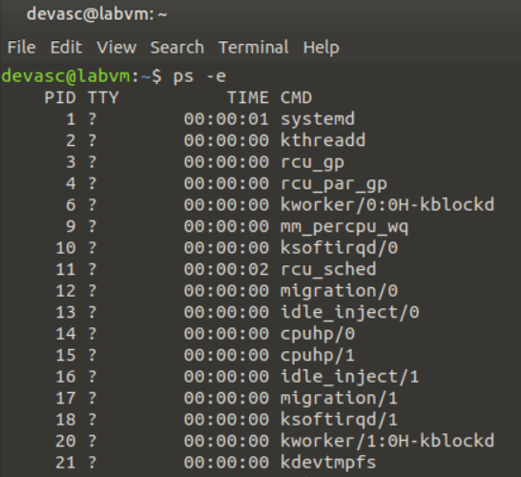

**Figure 15.2 Accessing the command “ps -e”.**

* + - 1. You can pipe any command output to one screen at a time by adding **| more**. One screen of output displays with the **--more--** shown at the bottom. You can now use the **Enter** key to display one line at a time, the **space bar** to display one screen at a time, or Ctrl+C to exit and return to the command prompt.

devasc@labvm:~$ **ps -e | more**

PID TTY TIME CMD

1 ? 00:00:01 systemd

2 ? 00:00:00 kthreadd

3 ? 00:00:00 rcu_gp

4 ? 00:00:00 rcu_par_gp

6 ? 00:00:00 kworker/0:0H-kblockd

9 ? 00:00:00 mm_percpu_wq

10 ? 00:00:00 ksoftirqd/0

--More--

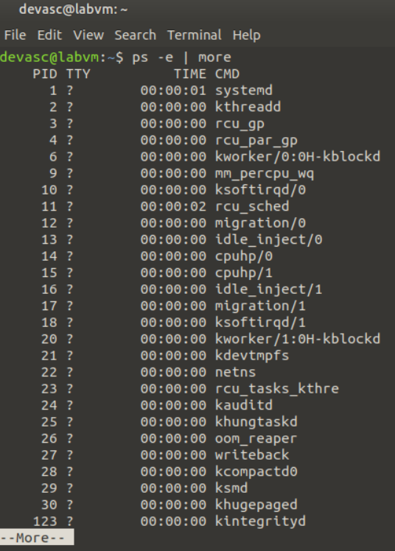

**Figure 15.3 Accessing the command “ps -e | more”.**

* + - 1. Use the **ps** with the **-ef** option to display all the processes that are running on the computer with more detail.

devasc@labvm:~$ **ps -ef**

UID PID PPID C STIME TTY TIME CMD

root 1 0 0 20:57 ? 00:00:01 /sbin/init

root 2 0 0 20:57 ? 00:00:00 [kthreadd]

root 3 2 0 20:57 ? 00:00:00 [rcu_gp]

root 4 2 0 20:57 ? 00:00:00 [rcu_par_gp]

root 6 2 0 20:57 ? 00:00:00 [kworker/0:0H-kblockd]

root 9 2 0 20:57 ? 00:00:00 [mm_percpu_wq]

root 10 2 0 20:57 ? 00:00:00 [ksoftirqd/0]

root 11 2 0 20:57 ? 00:00:01 [rcu_sched]

(output omitted)

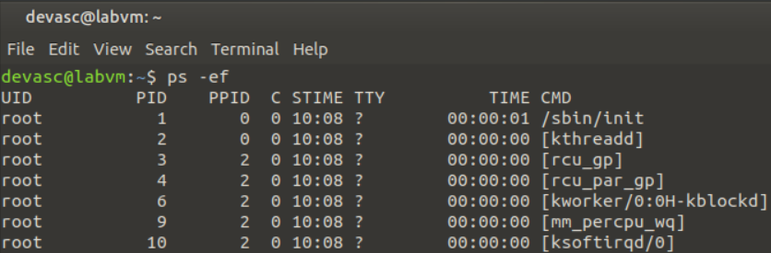

**Figure 15.4 Accessing the command “ps -ef”.**

### Manage packages.

* + - 1. Use the command **apt-get update** to refresh the list of available packages in the OS, as shown previously in Part 1 of this lab. You must use administrative level permissions to use this command.

devasc@labvm:~$ **sudo apt-get update**

Hit:1 http://security.ubuntu.com/ubuntu focal-security InRelease

Get:2 http://us.archive.ubuntu.com/ubuntu focal InRelease [265 kB]

Hit:3 http://us.archive.ubuntu.com/ubuntu focal-updates InRelease

Hit:4 http://us.archive.ubuntu.com/ubuntu focal-backports InRelease

Get:5 http://us.archive.ubuntu.com/ubuntu focal/main i386 Packages [721 kB]

Get:6 http://us.archive.ubuntu.com/ubuntu focal/main amd64 Packages [974 kB]

Get:7 http://us.archive.ubuntu.com/ubuntu focal/main Translation-en [506 kB]

(output omitted)

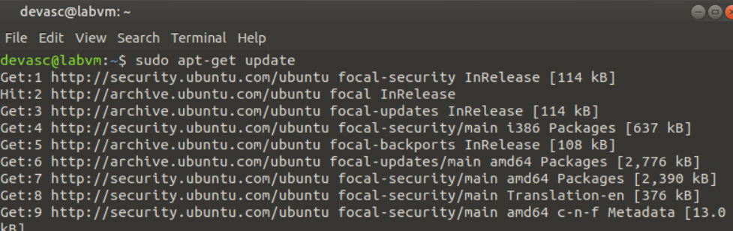

**Figure 16.1 Accessing the command “sudo apt-get update”.**

* + - 1. Use the command **apt-cache search** to find a specific package.

devasc@labvm:~$ **apt-cache search speed test**

(output omitted)

smalt-examples - Sequence Mapping and Alignment Tool (examples)

speedtest-cli - Command line interface for testing internet bandwidth using speedtest.net

sup - Software Upgrade Protocol implementation

sysbench - multi-threaded benchmark tool for database systems

tcpreplay - Tool to replay saved tcpdump files at arbitrary speeds (output omitted)

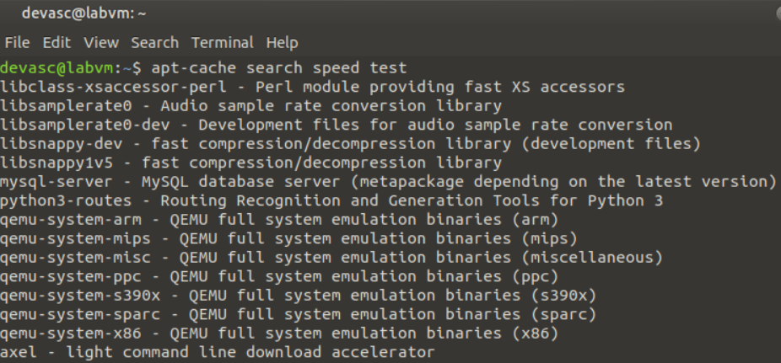

**Figure 16.2 Accessing the command “apt-cache search speed test”.**

* + - 1. Use the command **apt-get install** to install a package.

devasc@labvm:~$ **sudo apt-get install speedtest-cli**

Reading package lists... Done

Building dependency tree

Reading state information... Done

The following NEW packages will be installed:

speedtest-cli

0 upgraded, 1 newly installed, 0 to remove and 0 not upgraded.

Need to get 23.9 kB of archives.

After this operation, 106 kB of additional disk space will be used.

Get:1 http://archive.ubuntu.com/ubuntu focal/universe amd64 speedtest-cli all 2.1.2-2 [23.9 kB]

Fetched 23.9 kB in 1s (43.9 kB/s)

Selecting previously unselected package speedtest-cli.

(output omitted)

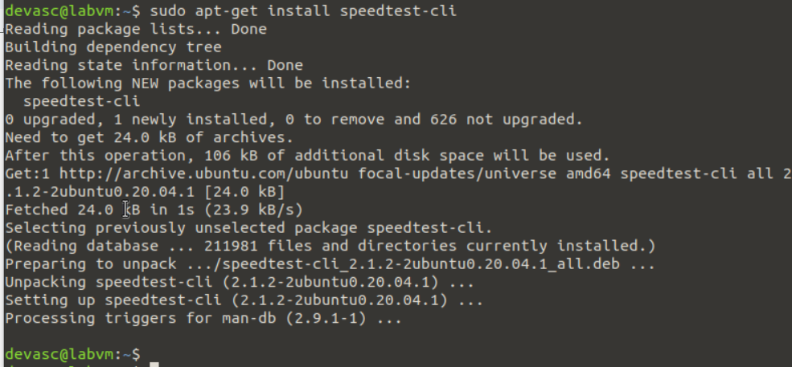

**Figure 16.3 Accessing the command “sudo apt-get install speedtest-cli”.**

* + - 1. Now you can use the **speedtest-cli** command to test your current Internet connection speed.

devasc@labvm:~$ speedtest-cli

Retrieving speedtest.net configuration...

Testing from Cable Company (192.168.100.21)...

Retrieving speedtest.net server list...

Selecting best server based on ping...

Hosted by Comcast (Albuquerque, NM) [494.76 km]: 48.636 ms

Testing download speed................................................................................

Download: 90.87 Mbit/s

Testing upload speed......................................................................................................

Upload: 17.87 Mbit/s

devasc@labvm:~$

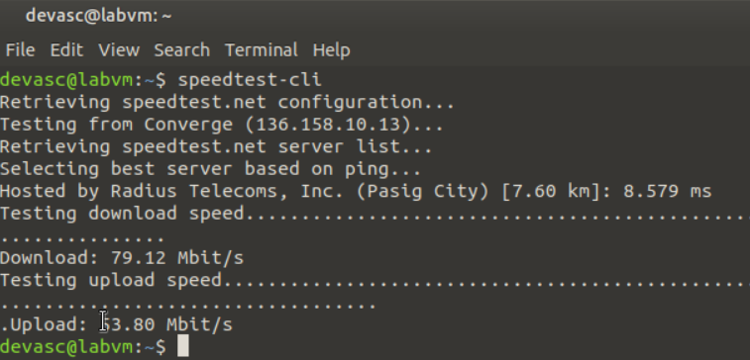

**Figure 16.4 Accessing the command “speedtest-cli”.**

* + - 1. Use the command **apt-get upgrade** to update all packages and dependencies on the computer.

devasc@labvm:~$ **sudo apt-get upgrade**

Reading package lists... Done

Building dependency tree

Reading state information... Done

Calculating upgrade... Done

The following packages have been kept back:

libnss-systemd libpam-systemd libsystemd0 libyelp0 linux-generic linux-headers-generic

(output omitted)

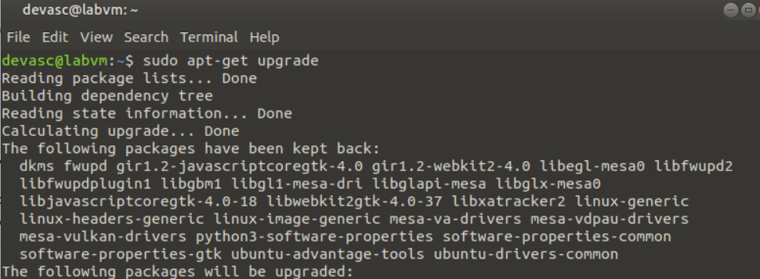

**Figure 16.5 Accessing the command “sudo apt-get upgrade”.**

* + - 1. Use the command **apt-get purge** to completely remove a package from the computer.

devasc@labvm:~$ **sudo apt-get purge speedtest-cli**

Reading package lists... Done

Building dependency tree

Reading state information... Done

The following packages will be REMOVED:

speedtest-cli*

0 upgraded, 0 newly installed, 1 to remove and 0 not upgraded.

After this operation, 106 kB disk space will be freed.

Do you want to continue? [Y/n]

(Reading database ... 211937 files and directories currently installed.)

Removing speedtest-cli (2.1.2-2) ...

(output omitted)

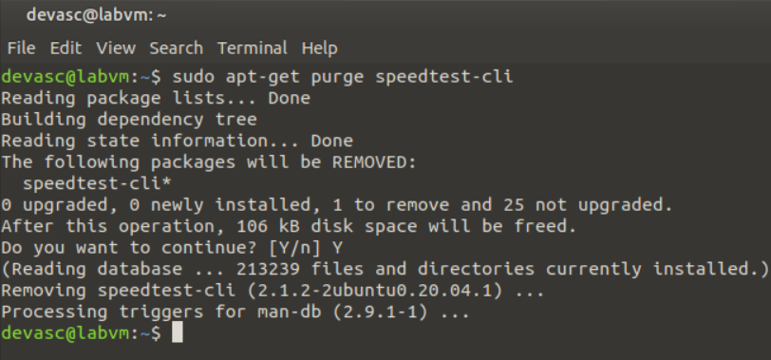

### Update Passwords

* + - 1. Use the command **passwd** to update your password.

**Note**: If you actually change the password for your devasc user, make sure you remember it.

devasc@labvm:~$ **passwd**

Changing password for devasc.

Current password:

New password:

Retype new password:

passwd: password updated successfully

devasc@labvm:~$

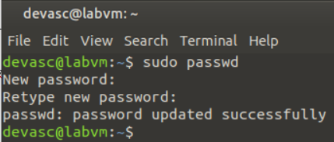

* + - 1. Use the command **passwd** with the option **-S** to view the status of your password.

devasc@labvm:~$ **passwd -S**

devasc P 04/17/2020 0 99999 7 -1

devasc@labvm:~$

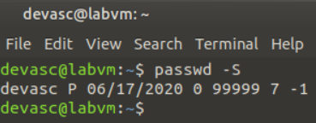

* + - 1. Use the manual pages for the **passwd** command (**man passwd**) to research the **-S** option and find the answer the following questions.

#### Questions

What is the current status of the password?

***P is the indicate usable password***

What is the minimum number of days that must pass before the password can be changed?

***0***

What is the number of days after password expiration that the account remains active?

***-1 is the password that never expires due to inactivity.***

In conclusion, this lab focused on reinforcing fundamental Linux skills essential for various tasks. Through the five parts of this lab, you engaged in activities that ranged from launching the DEVASC VM to delving into command syntax navigation, file management, regular expressions, and system administration. While this lab does not replace comprehensive prior Linux experience, it serves as an effective assessment of your current skill set and highlights areas that might require further review. The diverse range of tasks covered here provides a solid foundation for understanding Linux operations, which is invaluable in various technological and development contexts. As you progress, consider building upon these skills to confidently navigate and work within Linux environments, contributing to your overall proficiency in the field.